Lab 3 -a

Praneesh R V

CB.SC.U4CYS23036

Getfacl

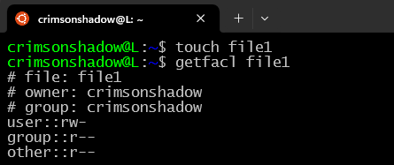

Setfacl

User

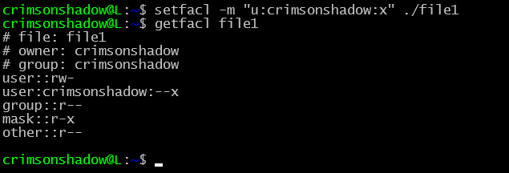

Group

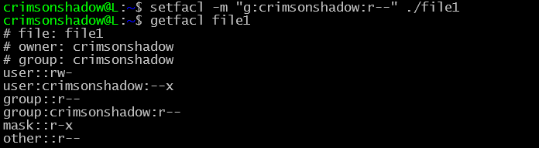

Directory

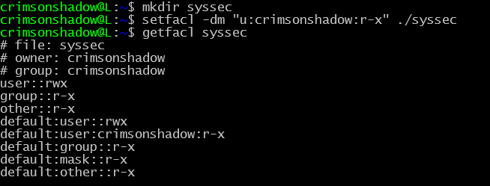

Deleting

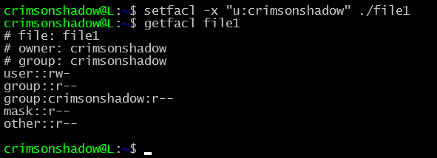

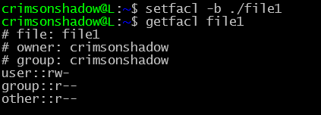

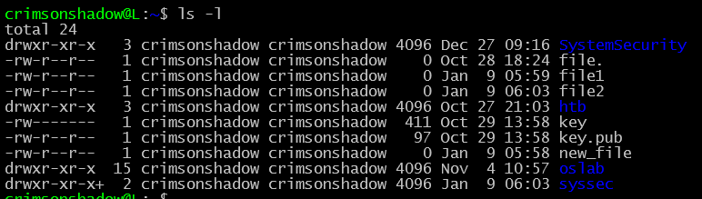

FILE PERMISSIONS AND OWNERSHIP

Changing file permissions numerically



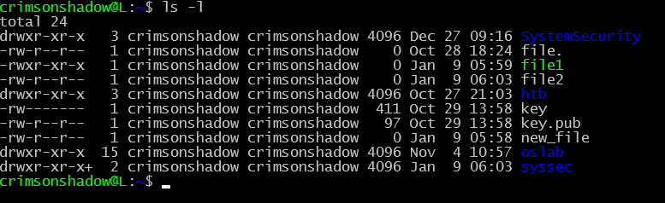

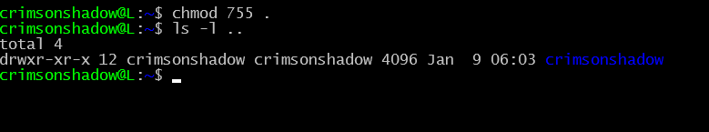

Chown





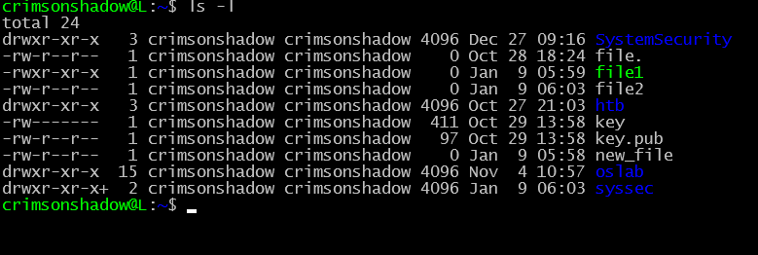

File types in linux

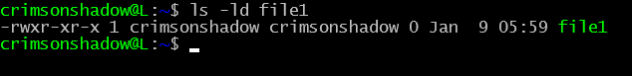

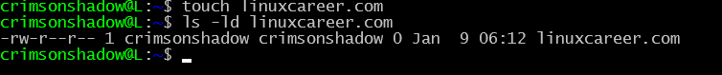

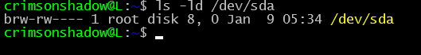

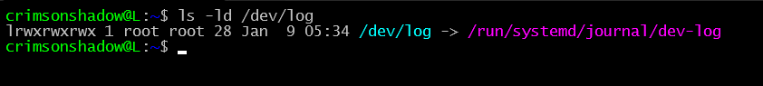

Pipes

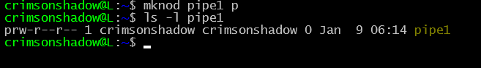

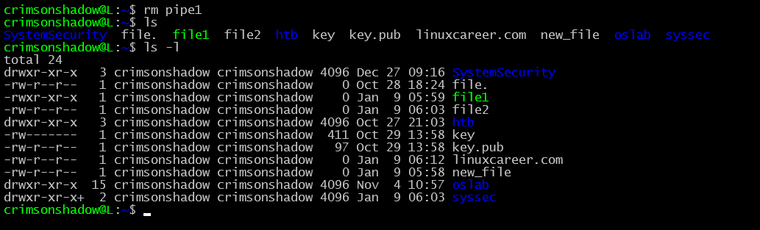

Links



